**Assignment-based Subjective Questions**

1. From your analysis of the categorical variables from the dataset, what could you infer about their effect on the dependent variable? (3 marks)

Categorical variables have significant impact on the target variable as seen from the box plot. Categorical variables season, yr, mnth, holiday, & weathersit have highest impact among categorical variables.

1. Why is it important to use drop_first=True during dummy variable creation? (2 mark)

drop_first=True drops the redundant dummy variable by setting the first dummy variable as the base variable. By doing this the model can be built with k-1 dummy variables for k levels of a categorical variable. Hence building a lean model.

1. Looking at the pair-plot among the numerical variables, which one has the highest correlation with the target variable? (1 mark)

Highest correlation was found to be with temp and atemp variables.

1. How did you validate the assumptions of Linear Regression after building the model on the training set? (3 marks)

After building the model, the error terms were analysed and found out that the error terms are normally distributed and centred around zero. This validates the assumptions of Linear Regression.

1. Based on the final model, which are the top 3 features contributing significantly towards explaining the demand of the shared bikes? (2 marks)

Year, temperature and light were found to be the top 3 features explaining the demand by looking at their coefficients.

**General Subjective Questions**

1. Explain the linear regression algorithm in detail. (4 marks)

Linear Regression is one of the most fundamental algorithms in the Machine Learning world which comes under supervised learning. Basically it performs a regression task. Regression models predict a dependent (target) value based on independent variables. It is mostly used for finding out the relationship between variables and forecasting. Different regression models differ based on – the kind of relationship between the dependent and independent variables, they are considering and the number of independent variables being used.

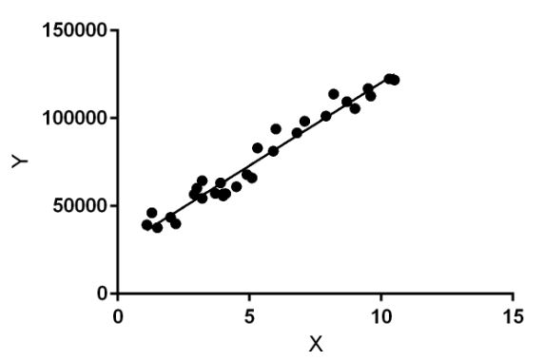

Linear regression performs the task to predict a dependent variable value (y) based on a given independent variable (x). So, this regression technique finds out a linear relationship between x (input) and y (output). Hence, the name is Linear Regression.

In the figure above, X (input) is the work experience and Y (output) is the salary of a person. The regression line is the best fit line for our model.

Linear Regression may further divided into

1. Simple Linear Regression/ Univariate Linear regression

2. Multivariate Linear Regression

1. Explain the Anscombe’s quartet in detail. (3 marks)

Anscombe’s quartet comprises four datasets that have nearly identical simple statistical properties, yet appear very different when graphed. Each dataset consists of eleven (x,y) points. They were constructed in 1973 by the statistician Francis Anscombe to demonstrate both the importance of graphing data before analyzing it and the effect of outliers on statistical properties. Those 4 sets of 11 data-points are given below.

1. What is Pearson’s R? (3 marks)

In Statistics, the Pearson's Correlation Coefficient is also referred to as Pearson's r, the Pearson product-moment correlation coefficient (PPMCC), or bivariate correlation. It is a statistic that measures the linear correlation between two variables. Like all correlations, it also has a numerical value that lies between -1.0 and +1.0.

Whenever we discuss correlation in statistics, it is generally Pearson's correlation coefficient. However, it cannot capture nonlinear relationships between two variables and cannot differentiate between dependent and independent variables.

Pearson's correlation coefficient is the covariance of the two variables divided by the product of their standard deviations. The form of the definition involves a "product moment", that is, the mean (the first moment about the origin) of the product of the mean-adjusted random variables; hence the modifier product-moment in the name.

Pearson's Correlation Coefficient is named after Karl Pearson. He formulated the correlation coefficient from a related idea by Francis Galton in the 1880s.

1. What is scaling? Why is scaling performed? What is the difference between normalized scaling and standardized scaling? (3 marks)

It is a step of data Pre-Processing which is applied to independent variables to normalize the data within a particular range. It also helps in speeding up the calculations in an algorithm.

Most of the times, collected data set contains features highly varying in magnitudes, units and range. If scaling is not done then algorithm only takes magnitude in account and not units hence incorrect modelling. To solve this issue, we have to do scaling to bring all the variables to the same level of magnitude.

It is important to note that scaling just affects the coefficients and none of the other parameters like t-statistic, F-statistic, p-values, R-squared, etc.

Normalization/Min-Max Scaling:

* It brings all of the data in the range of 0 and
* sklearn.preprocessing.MinMaxScaler helps to implement normalization in python.

Standardization Scaling:

Standardization replaces the values by their Z scores. It brings all of the data into a standard normal distribution which has mean (μ) zero and standard deviation one (σ).

* sklearn.preprocessing.scale helps to implement standardization in python.
* One disadvantage of normalization over standardization is that it loses some information in the data, especially about outliers.

1. You might have observed that sometimes the value of VIF is infinite. Why does this happen? (3 marks)

If there is perfect correlation, then VIF = infinity. This shows a perfect correlation between two independent variables. In the case of perfect correlation, we get R2 =1, which lead to 1/(1-R2) infinity. To solve this problem we need to drop one of the variables from the dataset which is causing this perfect multicollinearity.

1. What is a Q-Q plot? Explain the use and importance of a Q-Q plot in linear regression. (3 marks)

Q-Q Plots (Quantile-Quantile plots) are plots of two quantiles against each other. A quantile is a fraction where certain values fall below that quantile. For example, the median is a quantile where 50% of the data fall below that point and 50% lie above it. The purpose of Q Q plots is to find out if two sets of data come from the same distribution. A 45 degree angle is plotted on the Q Q plot; if the two data sets come from a common distribution, the points will fall on that reference line.